Notes on Optical Tunnel Design
J. Haupt
12/29/2014

What is the optimal geometry of an optical tunnel for a detector illuminated by a source (integrating sphere) at some distance?

The ideal setup places the source and detector inside a perfect black body. In practice one must chose some enclosure, using baffles to aid stray light suppression.
- Assuming the highest absorptivity coating available is chosen for all surfaces and keeping in mind that absorptivity will never be ideal, especially at grazing incidences, the problem is reduced to devising a geometry that eliminates all single-bounce specular reflections onto the detector and moreover maximizes the number of reflections for any given unwanted ray.
- For simplicity, the only tunnel form considered is a tube with flat endcaps and the only baffles considered are flat planes with circular apertures, parallel with the tube endcaps. For a system of given detector size, source aperture, and detector-source distance, the parameters that fully describe the tunnel are tube diameter, baffle quantity, longitudinal baffle positions, and the baffle aperture diameters.

It is shown pictorially that as the tube diameter is increased the quantity of baffles needed to eliminate single-bounce specular or diffuse reflections can be reduced to 1. Although a minimal quantity of representative rays are traced, it can be shown that these scenarios are true for all possible ray scattering conditions.

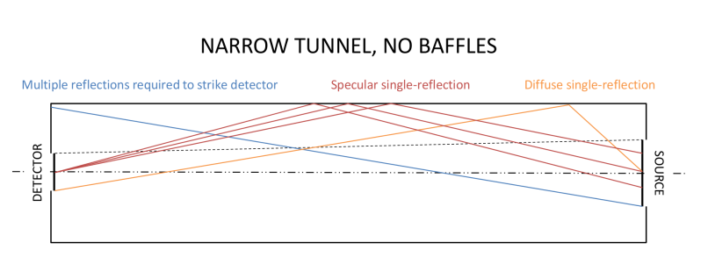 | -A tunnel without baffles is prone to direct specular and diffuse reflection. As tunnel diameter is decreased specular reflections approach grazing incidence (cosine 1). The limit of a small diameter tunnel is a light pipe.
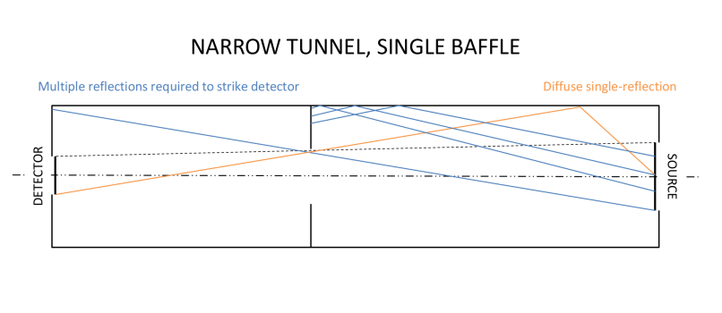 | -In a tunnel of sufficiently large diameter, for any given combination of detector size, source size, and detector-source distance, there exists a unique baffle position and aperture that eliminates all specular reflections that would reach the detector after only one bounce. Below a certain tunnel diameter an increasing number of baffles are required to do this.
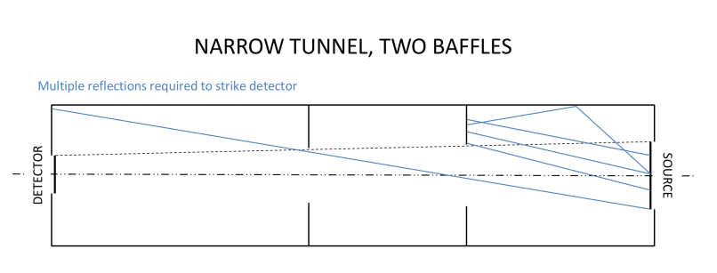 | -In a tunnel of sufficiently large diameter, for any given combination of detector size, source size, and detector-source distance, there exists a unique baffle position and aperture that eliminates all diffuse reflections that would reach the detector after only one bounce. Below a certain tunnel diameter an increasing number of baffles are required to do this.
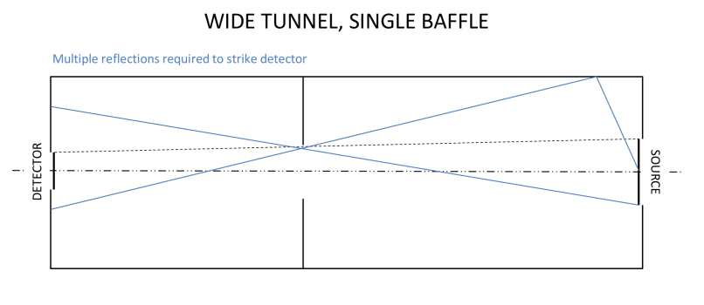 | -In a tunnel of sufficiently large diameter, for any given combination of detector size, source size, and detector-source distance, there exists a unique position and aperture for a single baffle that eliminates all reflections that would reach the detector after only one bounce.

A good design recognizes that increasing baffle quantity is not a panacea for suppressing stray light. Baffle edges “glint” however thin they may be and without rigorous analysis one wonders if baffles are doing more harm than good.

In all cases the optical tunnel should be designed to have as few exposed baffles as possible; in particular, one baffle placed as shown below is maximally effective as long as the tunnel’s aspect ratio is sufficiently squat.

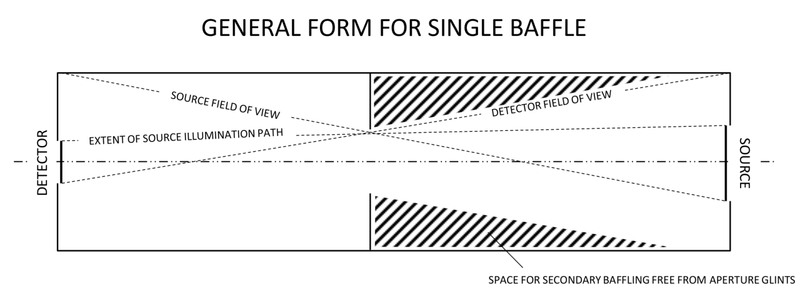
If desired, additional “secondary” baffles can be placed at will in the hatched region shown with no risk of exposing the detector to glints. Installing baffles in this region assures their apertures are completely hidden from the view of the detector.

NOTE: The simplification was made that the detector is coincident with the end wall of the optical tunnel. In the case of an imaging detector inside a chamber, the end wall becomes either the boundary of the detector’s chamber or an explicit field stop. This implies that in practice the detector can be exposed to no fewer than two apertures. In any case, any means of reducing the aperture glints is expected to be employed (e.g. flocking, painting, and/or sharpening the edges).

Parametric formula:

INPUT | $r_{s}$: Source radius  OUTPUT  $r_{d}$: Detector radius (or diagonal)  $z_{T}$: Tunnel length |  | $r_{T}$: Minimum tunnel radius  $r_{B}$: Baffle aperture radius  $z_{B}$: Distance of baffle from source

$$r_{T}=\frac{1}{2}\left[r_{s}+r_{d}+{\left(r_{s}^{2}+14r_{s}r_{d}+r_{d}^{2}\right)}^{1/2}\right]$$

$$r_{B}=\frac{r_{T}^{2}-r_{d}r_{s}}{2r_{T}+r_{d}+r_{s}}$$

$$z_{B}=\left|\frac{z_{T}(r_{B}-r_{s})}{r_{d}-r_{s}}\right|$$

